Sammar .T. El-Rouby
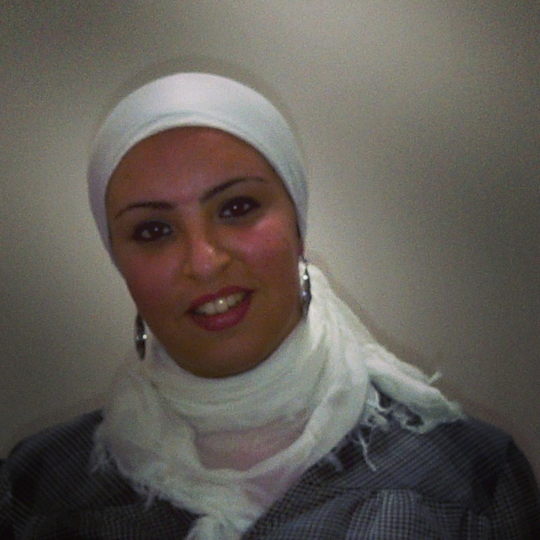
Sharjah, United Arab Emirates
Email: sammar_elrouby@hotmail.com

Mobile: 00971562115910

Personal Info
- Date of Birth : 09 / July / 1988
- Nationality : Egyptian
- Marital Status : Married
- Visa Status : UAE. Resident.
- UAE. Driving License : Available
- MOH License : Available

EDUCATION
2012 – 2013 Arab Academy for science, Technology & Maritime. Cairo, Egypt
Program: Post graduate diploma in business administration

2005-2010 MSA University Cairo, Egypt
Program: Bachelor of Pharmaceutical Science
2005-2010 Greenwich University England
Program: Bachelor of Pharmaceutical Science

2005 Pyramids Language School Cairo, Egypt
Program: American Diploma

EXPERIENCE
- From December 2015 to March 2016 : Working as a Freelance Market Research Executive in AC Neilsen Company – Sharjah -U.A.E
- From March 2015 to October 2015: Working as Freelance Market Research Executive in Euromonitor Company – Dubai – U.A.E.
- From October 2010 to May 2014: Working as a part time Community pharmacist in Dr Ehab Elkobra Pharmacy – Giza- Egypt.
- From June 2012 to February 2014: Working as a Quality Assurance Specialist in Heinz Multinational Company – 6Th October City – Cairo- Egypt.
- From May 2011 to May 2012: Working as a Quality Assurance Specialist in Fridal Company – 6Th October City – Cairo- Egypt.
- From October 2010 to April 2011: Working as a Medical Representative in Rameda Pharmaceutical Company – Giza – Egypt.

SKILLS AND INTERESTS
General Skills:
- Languages: -Arabic: Fluent (reading | writing | speaking) - English: Fluent (reading | writing | speaking)
- Strong relation building skills, Great in team work.
- High organization skills
- Ability to work well under pressure
- Fast learner

Technical Skills:
- Proficient knowledge of Microsoft Office.
References Available Upon Request

